Password Strength Checker
Goal:
Build a CLI tool that:
- Rates a password (0-100)
- Labels it (Very Weak -> Very Strong)
- Explains “why” and “how” to improve
Features:
- Inputs
Support both:
- Argument Mode: python main.py “MyPass123!”
- Interactive Mode: prompt the user
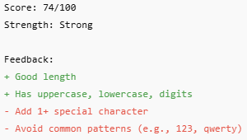
- Outputs
Scoring Model (0-100)
- Length Score (0-40)
Length is the most important attribute, so its weight is heaviest
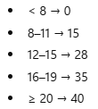
- Character Variety (0-25)
Add points for each category present (e.g. lowercase, uppercase, digit etc.)
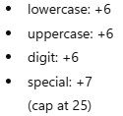
- Entropy-Ish bonus (0-15)
Reward uniqueness to avoid things like “Aaaaaa1111!”
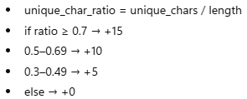
- Penalties (0-40 total)
Subtract for common weakness patterns:
- common password list (big impact)
- character repeats
- sequences
- Final
final = clamp(length + variety + uniqueness – penalties, 0, 100)
Strength Labels
Map score to a label:
- 0-24: Very Weak
- 25-44: Weak
- 45-64: Medium
- 65-84: Strong
- 85-100: Very Strong
Design Code Architecture
Folder/Files
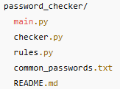

Responsibilities
rules.py
- Functions that return:
  - Points to add
  - Penalties to subtract
  - Feedback strings

checker.py
- Combines all rules
- Produces a result object:
  - Score
  - Label
  - Positives
  - Negatives
main.py
- Handles cli algorithms / interactive prompts
- Calls checker functions
- Prints formatted output
Data: common_passwords.txt
Keep it relatively small (100-1000 entries) – can expand later
Edge Cases
- Empty password
- Very long password (don’t crash)
- Unicode characters
- Password with spaces (allow, but warn)
README Outline
Include:
- What it does
- How to run (arg + interactive)
- How scoring works
- Example output
- Future improvements

